HS-485HB Servo Specs

[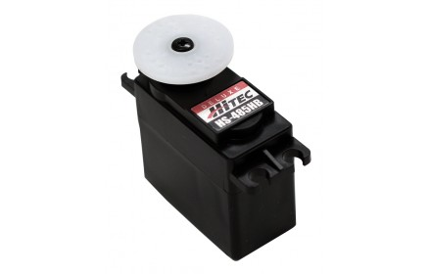](https://www.servocity.com/media/catalog/product/cache/1/image/9df78eab33525d08d6e5fb8d27136e95/h/s/hs-485hb_33485s_main_3.jpg)The HS-485HB updates the very popular HS-475HB by adding more torque and greater speed. With its top ball bearing, heavy duty, high impact Karbonite™ gears and high performance circuitry, the HS-485HB offers lots of torque and features excellent centering and resolution.

|  |  |
| --- | --- |
| Standard Servo Schematic 2 | **A** = .780” (19.82mm) **B** = .547” (13.9mm) **C** = 1.352” (34.35mm) **D** = .394” (10mm) **E** = .394” (10mm) **F** = 1.181” (30mm) **G** = .472” (12mm) **H** = 1.102” (28mm) **J** = 2.09” (53.1mm) **K** = .384” (9.75mm) **L** = .174” (4.42mm) **M** = 1.575” (40mm) **X** = .126” (3.2mm) |

|  |  |
| --- | --- |
| **Dimensions** | 1.57" x 0.78" x 1.49" (39.88 x 19.81 x 37.85mm) |
| **Product Weight** | 1.59oz (45g) |
| **Output Shaft Style** | 24 tooth ([C1](https://www.servocity.com/hitec-servo-spline-info/)) spline |
| **Voltage Range** | 4.8V - 6.0V |
| **No-Load Speed (4.8V)** | 0.22sec/60° |
| **No-Load Speed (6.0V)** | 0.18sec/60° |
| **Stall Torque (4.8V)** | 66.6 oz/in. (4.8kg.cm) |
| **Stall Torque (6.0V)** | 83.3 oz/in. (6.0kg.cm) |
| **Max PWM Signal Range (Standard)** | 553-2425μsec |
| **Travel per µs (out of box)** | .102°/μsec |
| **Max Travel (out of box)** | 190.5° |
| **Pulse Amplitude** | 3-5V |
| **Operating Temperature** | -20°C to +60°C |
| **Current Drain - idle (4.8V)** | 8mA |
| **Current Drain - idle (6.0V)** | 8.8mA |
| **Current Drain - no-load (4.8V)** | 150mA |
| **Current Drain - no-load (6V)** | 180mA |
| **Continuous Rotation Modifiable** | Yes |
| **Direction w/ Increasing PWM Signal** | Clockwise |
| **Deadband Width** | 8µs |
| **Motor Type** | 3 Pole Ferrite |
| **Potentiometer Drive** | Indirect Drive |
| **Feedback Style** | 5KΩ Potentiometer |
| **Output Shaft Support** | Top Ball Bearing, Bottom Bushing |
| **Gear Type** | Straight Cut Spur |
| **Gear Material** | Karbonite |
| **Wire Length** | 11.81" (300mm) |
| **Wire Gauge** | 25AWG |